**JENKINS END TO END IMPLEMENTATION - CICD PROJECT**

# **Jenkins Pipeline for Java based application using Maven, SonarQube, Argo CD and Kubernetes (KIND)**

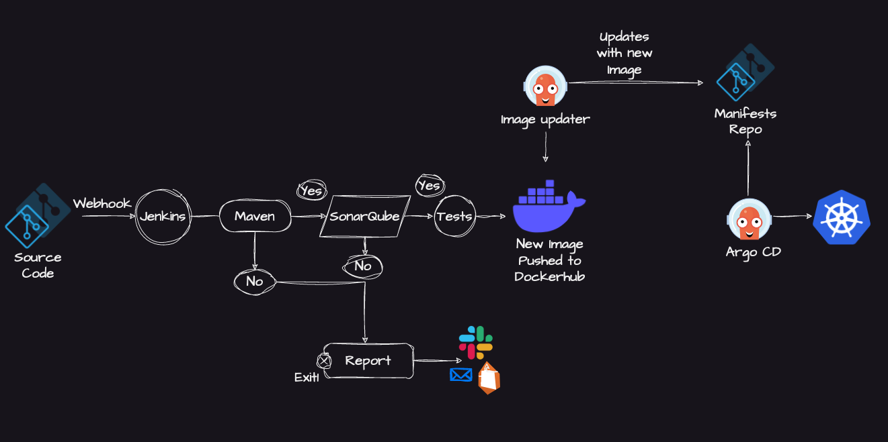

**Prerequisites:**

* Java application hosted on a Git repository
* EC2 instances (t2.large): 2
* Java: Jdk17
* Jenkins
* Docker
* Docker Hub image repository
* SonarQube
* Kind and Kubectl
* ArgoCD

# Install Java, Jenkins, Docker and SonarQube on EC2 instance (t2.large)

```

sudo apt update

sudo apt install openjdk-17-jdk -y

java -version

```

# Jenkins requires Java (done in Step 1), so now install Jenkins:

```

curl -fsSL https://pkg.jenkins.io/debian-stable/jenkins.io-2023.key | sudo tee \

/usr/share/keyrings/jenkins-keyring.asc > /dev/null

echo deb [signed-by=/usr/share/keyrings/jenkins-keyring.asc] \

https://pkg.jenkins.io/debian-stable binary/ | sudo tee \

/etc/apt/sources.list.d/jenkins.list > /dev/null

sudo apt update

sudo apt install jenkins -y

```

# Start and enable jenkins:

```

sudo systemctl start jenkins

sudo systemctl enable jenkins

```

```

sudo systemctl status jenkins

```

# Open Jenkins in your browser:

```

http://public-ip:8080

```

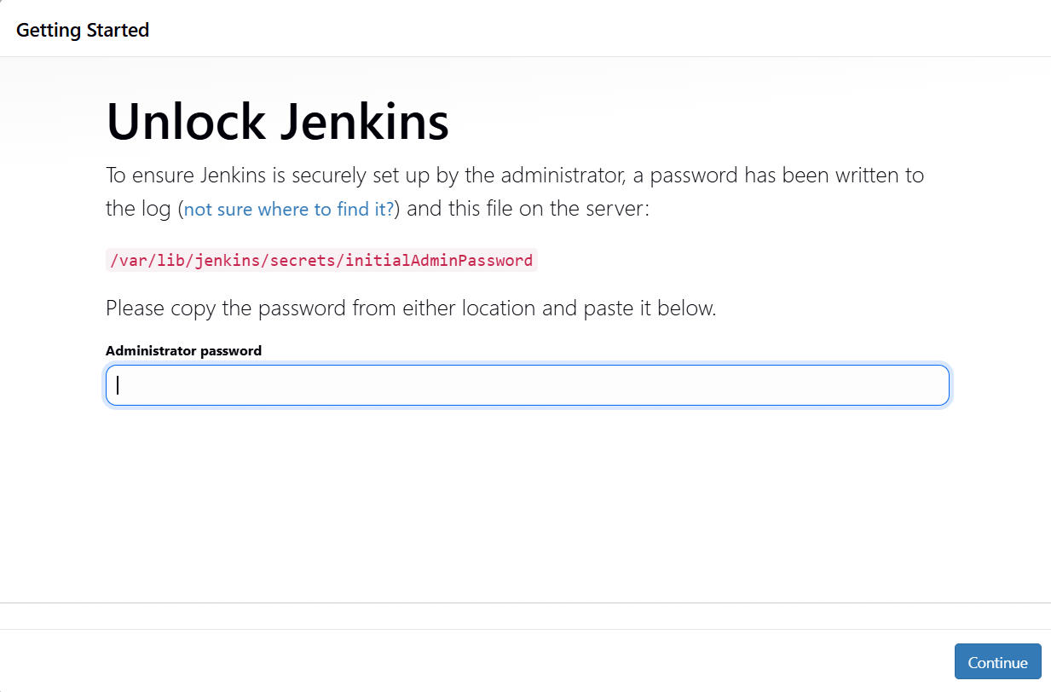

# To get the initial admin password:

```

sudo cat /var/lib/jenkins/secrets/initialAdminPassword

```

# Install suggested plugins on jenkins:

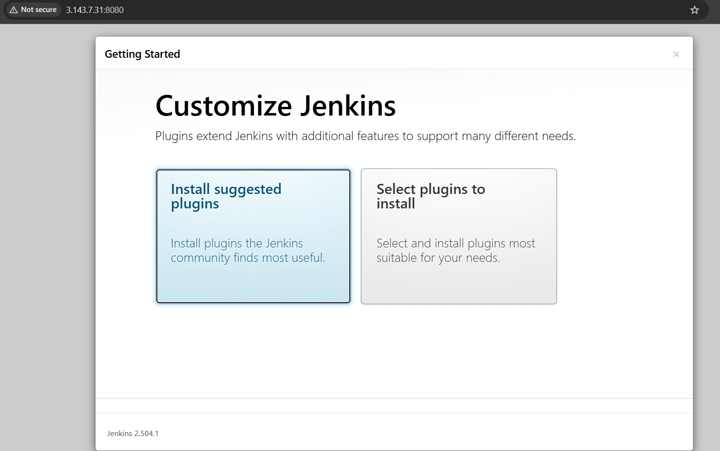

# Install Docker:

```

sudo apt install docker.io -y

```

# # Grant permission to Ubuntu user and jenkins user to docker daemon:

```

sudo usermod -aG docker $USER

sudo usermod -aG docker jenkins

sudo systemctl restart docker

```

# Run SonarQube using Docker as container:

```

docker run -d --name sonar -p 9000:9000 sonarqube:lts-community

```

# Check sonar container running:

```

docker ps

```

# Access sonarqube server on:

```

<http://public-ip:9000>

```

# Create access token for jenkins:

Goto administration -> security -> users -> update token to 1,Generate token - name it (copy this to create credentials for jenkins)

# Install Available plugins:

Goto Manage Jenkins -> plugins

* Docker
* Sonarqube scanner

# Create Jenkins global credentials:

Goto Manage Jenkins -> credentials

Docker Hub (kind - username and password) - ID - docker-cred

SonarQube (kind - secret text) - ID - sonar [Go to sonarqube server->administration->security-> users -> Generate token and copy it for future use]

Github (kind - secret text) - ID - github [Create access token from github profile -> settings -> personal access token classic]

# Create job

Name

Description

Select Pipeline - Pipeline script from SCM

SCM - Git

Git Repository URL - <https://github.com/ritikasharm1505/Jenkins-Zero-To-Hero>

Branch specifier - */main

Script Path - java-maven-sonar-argocd-helm-k8s/spring-boot-app/JenkinsFile

Apply and Save

Configure build:

Update the Sonar-server URL and credentials in the JenkinsFile according to yours

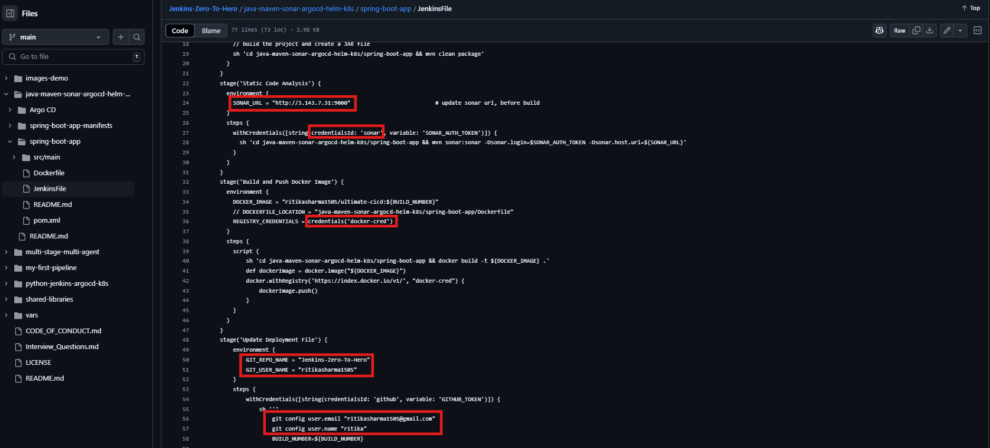

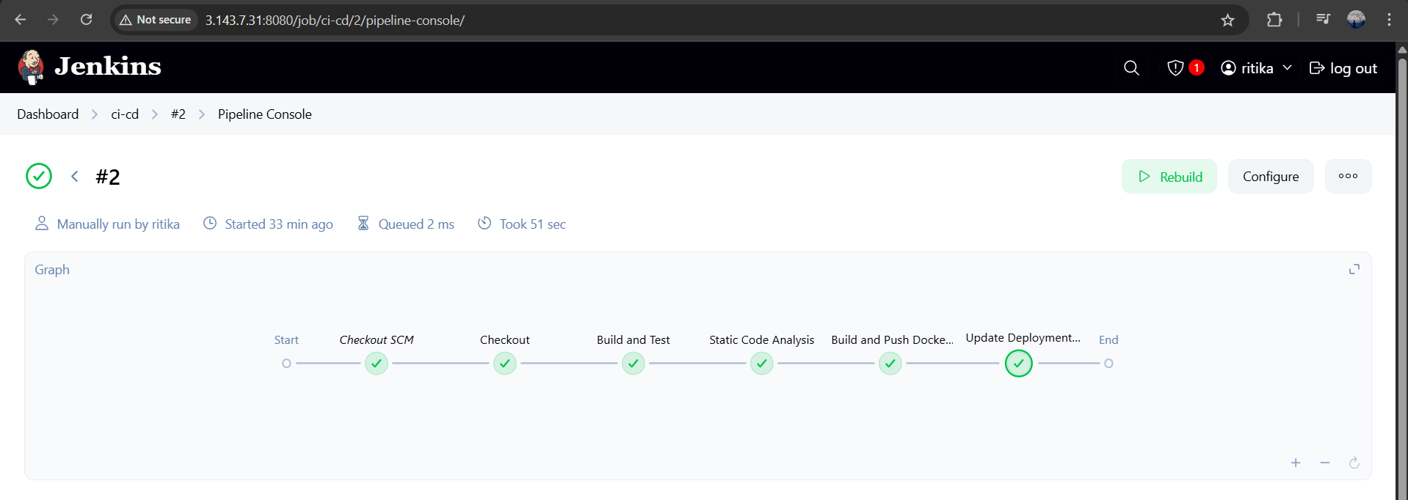

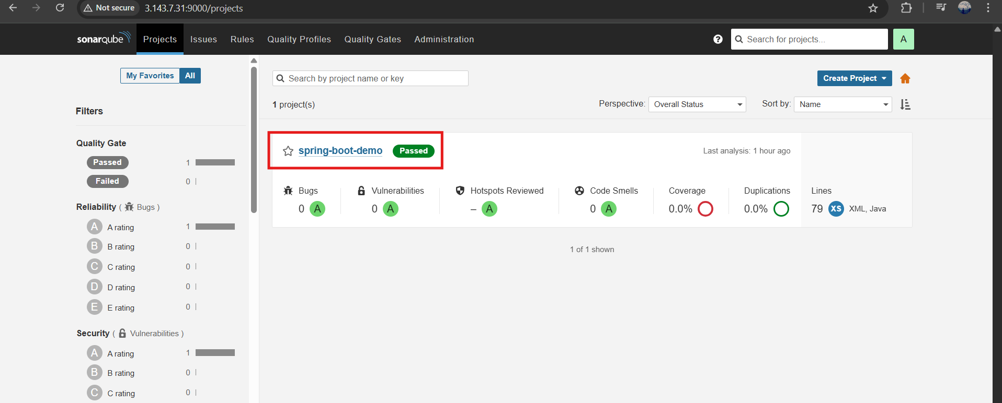

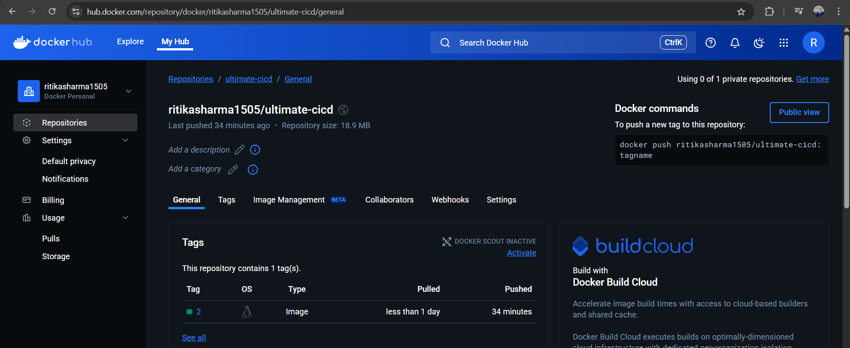

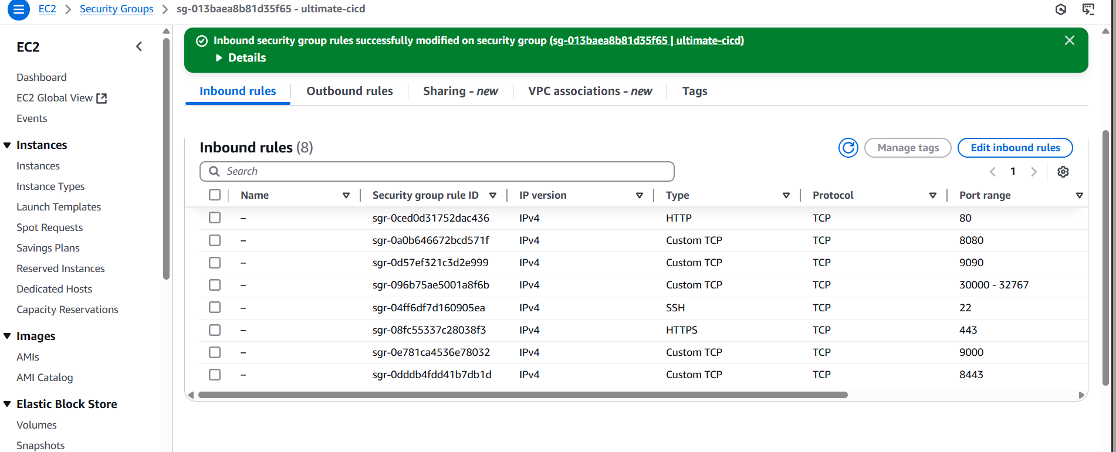

Now, let’s setup Kubernetes cluster (Kind) and ArgoCD to deploy the spring boot application

# Update packages and Install docker:

```

sudo apt update

sudo apt install docker.io -y

```

# Give permissions to user

```

sudo usermod -aG docker $USER

```

# Install Kind and Kubectl:

create vi kind.sh

```

#!/bin/bash

[ $(uname -m) = x86_64 ] && curl -Lo ./kind https://kind.sigs.k8s.io/dl/v0.27.0/kind-linux-amd64

chmod +x ./kind

sudo mv ./kind /usr/local/bin/kind

VERSION="v1.30.0"

URL="https://dl.k8s.io/release/${VERSION}/bin/linux/amd64/kubectl"

INSTALL_DIR="/usr/local/bin"

curl -LO "$URL"

chmod +x kubectl

sudo mv kubectl $INSTALL_DIR/

kubectl version --client

rm -f kubectl

rm -rf kind

echo "kind & kubectl installation complete."

```

# Give permissions to execute and run script:

```

sudo chmod +x kind.sh

./kind.sh

```

# Setting up the KIND cluster:

Create a kind-cluster-config.yaml file:

```

kind: Cluster

apiVersion: kind.x-k8s.io/v1alpha4

nodes:

- role: control-plane

image: kindest/node:v1.31.2

- role: worker

image: kindest/node:v1.31.2

- role: worker

image: kindest/node:v1.31.2

```

# Create the cluster using the configuration file:

```

kind create cluster --config kind-cluster-config.yaml --name ci-cd

```

# Verify the cluster:

```

kubectl get nodes

kubectl cluster-info

```

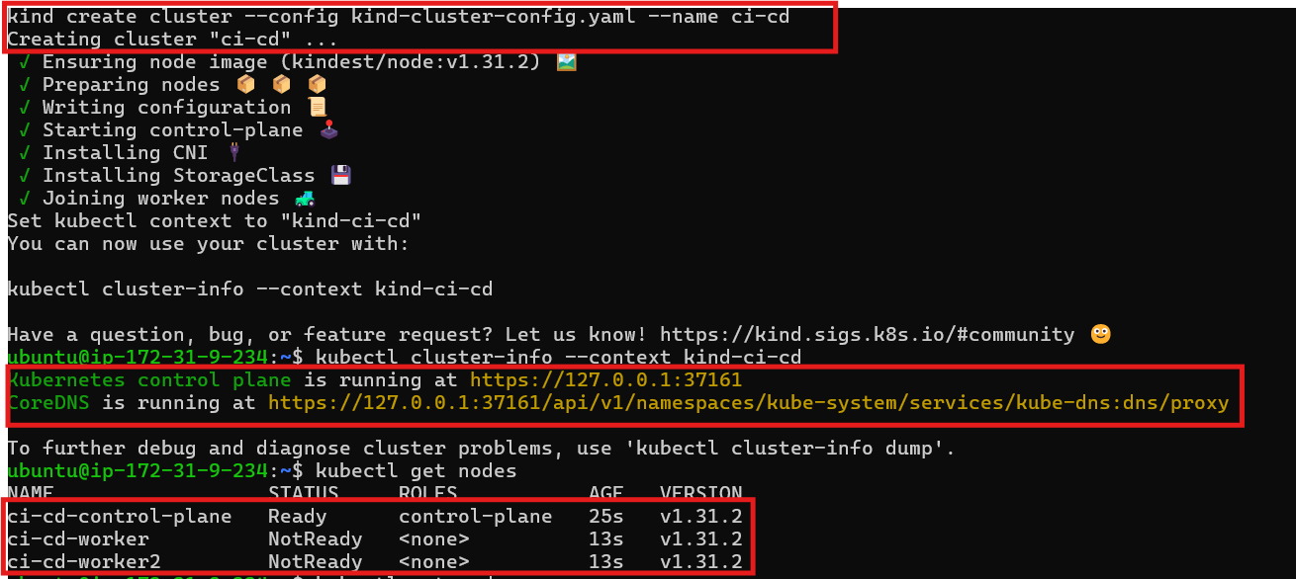

# Install ArgoCD:

Create a namespace for ArgoCD:

```

kubectl create namespace argocd

```

Apply the ArgoCD manifest:

```

kubectl apply -n argocd <https://raw.githubusercontent.com/argoproj/argo-cd/stable/manifests/install.yaml>

```

Check services in ArgoCD namespace:

```

kubectl get svc -n argocd

```

Expose ArgoCD server using nodeport:

```

kubectl patch svc argocd-server -n argocd -p '{"spec": {"type": "NodePort"}}'

```

Port forward to access ArgoCD server:

```

kubectl port-forward -n argocd service/argocd-server 8443:443 --address=0.0.0.0 &

```

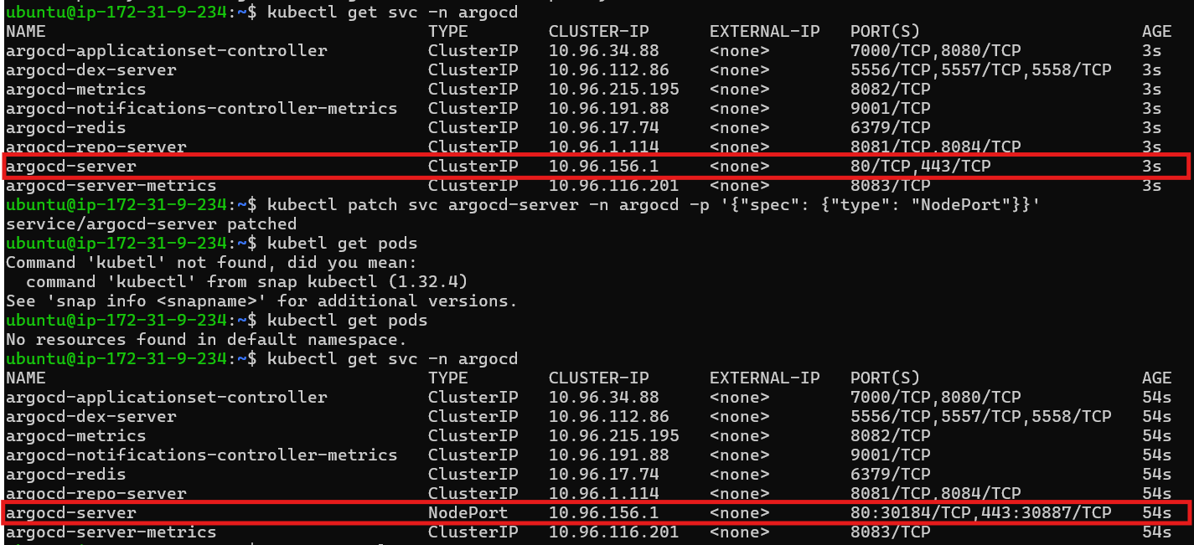

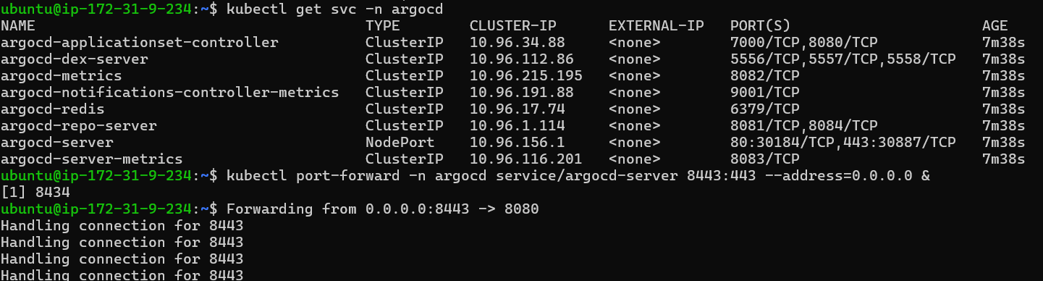

Access ArgoCD UI on browser:

```

https://public-ip:8443

```

Retrieve ArgoCD Initial password:

```

kubectl get secret -n argocd argocd-initial-admin-secret -o jsonpath="{.data.password}" | base64 -d && echo

```

Create Application:

Name

Default

Repo URL -

Path -

Namespace - default

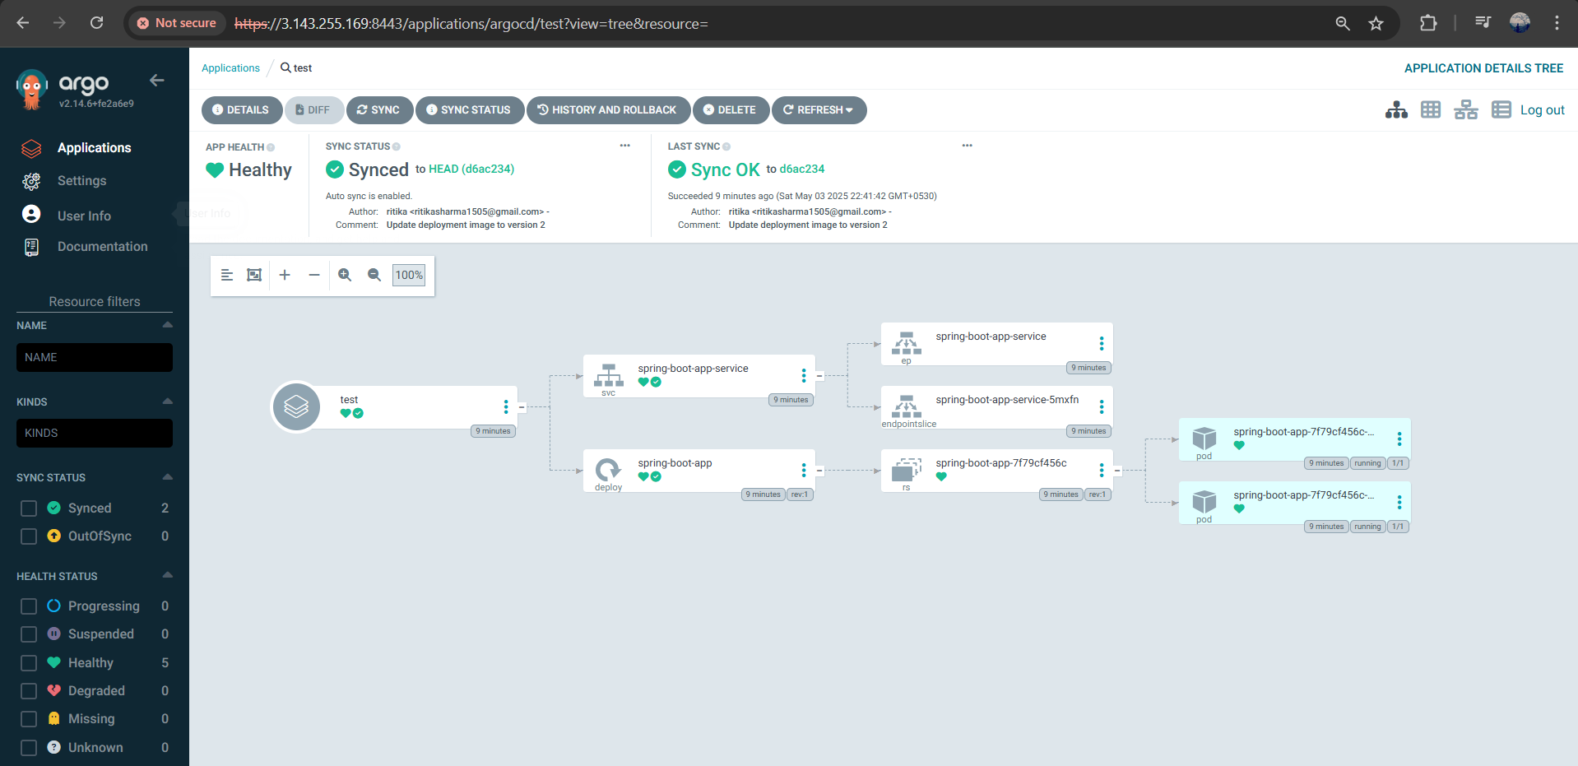

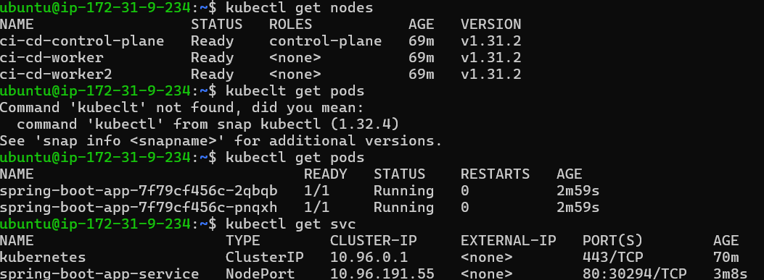

To access the spring boot app port forward:

```

kubectl port-forward pod/<podname> 9090:8080 --address=0.0.0.0 &

```



Finally, access the spring boot app on the browser 👏

```

<http://public-ip:9090>

```

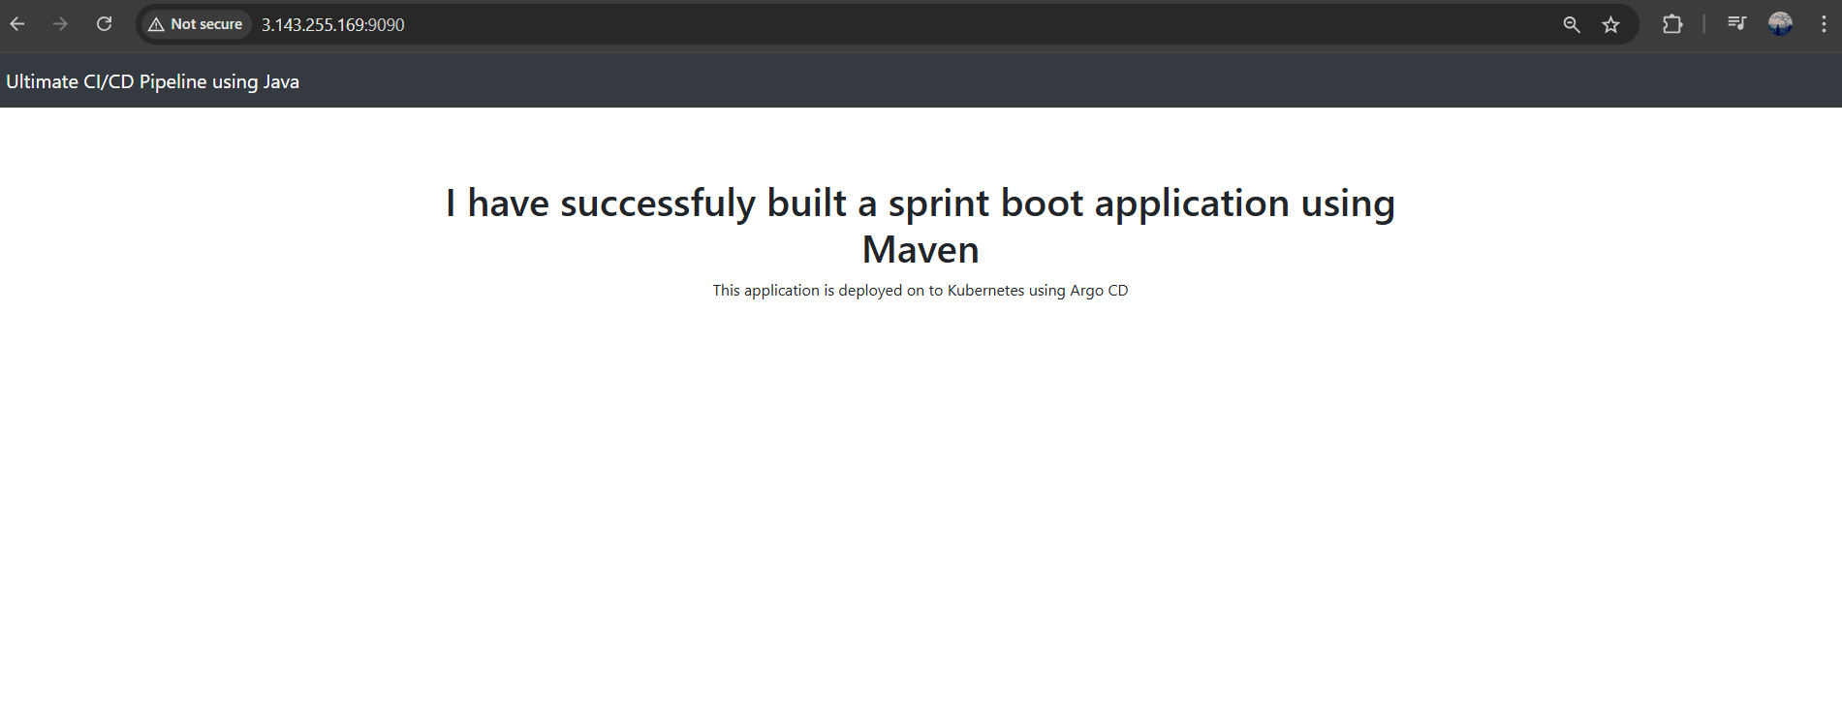

---------------------------------------------------------------------------------------------------------------------

HAPPY LEARNING 👍